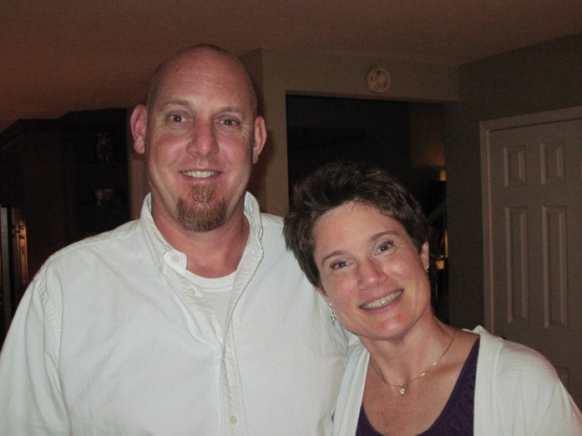

Brian Crenshaw & sister, Elaine Katherine Moore - 2013



Elaine Katherine Moore – 2013